INDIVIDUAL ACTIVITY

**5. Create a Complete Cucumber framework with all possible features , check-in code to git and execute the tests using Jenkins**

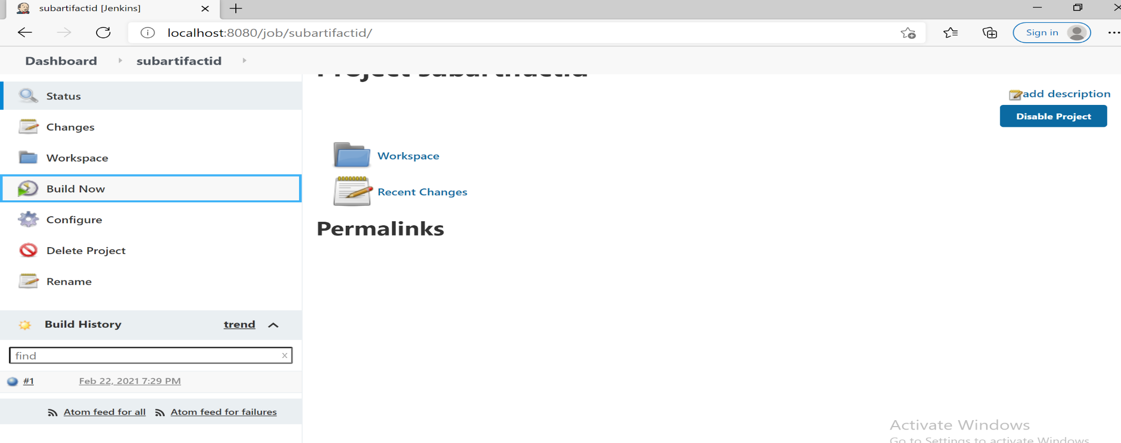

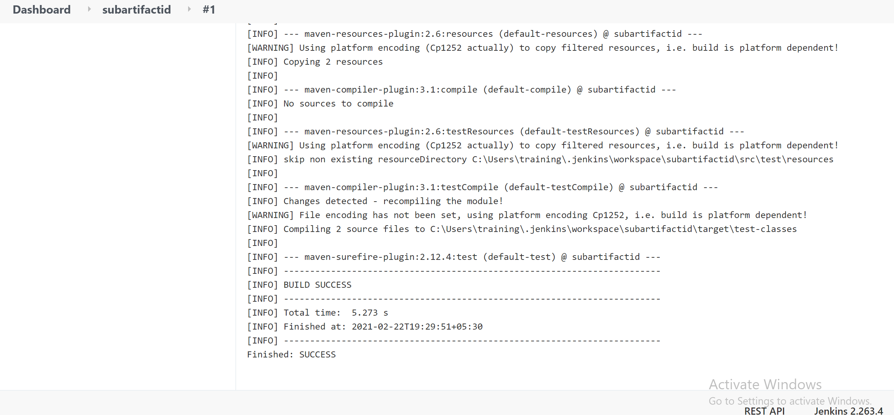

**1) Automate Registration of user**

**Application URL:** [**http://demo.guru99.com/test/newtours/register.php**](http://demo.guru99.com/test/newtours/register.php)

1. **Create a Maven Project and automate scenarios from the above link**
2. **Print all the values in the Country drop down to the console**
3. **Include assertion Post submission of registration & Take Screenshot for success & failure**
4. **Execute the test for multiple records (parameterize)**
5. **Execute the test using Maven Commands**

**package** subjectiveartifactid;

**import** java.io.File;

**import** java.io.IOException;

**import** java.util.List;

**import** java.util.concurrent.TimeUnit;

**import** org.openqa.selenium.By;

**import** org.openqa.selenium.OutputType;

**import** org.openqa.selenium.TakesScreenshot;

**import** org.openqa.selenium.WebDriver;

**import** org.openqa.selenium.WebElement;

**import** org.openqa.selenium.chrome.ChromeDriver;

**import** org.openqa.selenium.io.FileHandler;

**import** org.openqa.selenium.support.ui.Select;

**public** **class** Drop {

**public** **static** **void** main(String[] args) **throws** InterruptedException, IOException {

System.*setProperty*("webdriver.chrome.driver", "C:\\Users\\training\\eclipse-workspace\\subartifactid\\src\\main\\resources\\chromedriver.exe");

WebDriver x=**new** ChromeDriver();

x.get("http://demo.guru99.com/test/newtours/register.php");

x.manage().timeouts().implicitlyWait(5, TimeUnit.***SECONDS***);

Thread.*sleep*(3000);

System.***out***.println("CONTACT INFORMATION");

WebElement element1=x.findElement(By.*name*("firstName"));

element1.sendKeys("Dharini");

String a=element1.getAttribute("value");

System.***out***.println("First Name: "+a);

Thread.*sleep*(1000);

WebElement element2=x.findElement(By.*name*("lastName"));

element2.sendKeys("Kavitha");

String b=element2.getAttribute("value");

System.***out***.println("Last Name: "+b);

Thread.*sleep*(1000);

WebElement element3=x.findElement(By.*name*("phone"));

element3.sendKeys("9626058259");

String c=element3.getAttribute("value");

System.***out***.println("Phone: "+c);

Thread.*sleep*(1000);

WebElement element4=x.findElement(By.*name*("userName"));

element4.sendKeys("dharinikavitha@gmail.com");

String d=element4.getAttribute("value");

System.***out***.println("Email: "+d);

System.***out***.println("----------------------------------");

System.***out***.println("MAILING INFORMATION");

WebElement element5=x.findElement(By.*name*("address1"));

element5.sendKeys("union bank colony,villangudi");

String e=element5.getAttribute("value");

System.***out***.println("Address: " +e);

Thread.*sleep*(1000);

WebElement element6=x.findElement(By.*name*("city"));

element6.sendKeys("Madurai");

String f=element6.getAttribute("value");

System.***out***.println("City: "+f);

Thread.*sleep*(1000);

WebElement element7=x.findElement(By.*name*("state"));

element7.sendKeys("Tamil Nadu");

String g=element7.getAttribute("value");

System.***out***.println("State/Province: "+g);

Thread.*sleep*(1000);

WebElement element8=x.findElement(By.*name*("postalCode"));

element8.sendKeys("625 018");

String h=element8.getAttribute("value");

System.***out***.println("Postal Code: "+h);

Thread.*sleep*(1000);

Select drpcountry=**new** Select(x.findElement(By.*name*("country")));

List<WebElement> el=drpcountry.getOptions();

**int** iListsize=el.size();

System.***out***.println("Total no. of Countries: "+iListsize);

**for**(**int** i=0;i<iListsize;i++)

{

String cntry=drpcountry.getOptions().get(i).getText();

System.***out***.println("Country "+(i+1)+" :"+cntry);

}

drpcountry.selectByVisibleText("INDIA");

Thread.*sleep*(1000);

System.***out***.println("----------------------------------");

System.***out***.println("USER INFORMATION");

WebElement element9=x.findElement(By.*name*("email"));

element9.sendKeys("Dharini");

String i=element9.getAttribute("value");

System.***out***.println("User Name: "+i);

Thread.*sleep*(1000);

WebElement element10=x.findElement(By.*name*("password"));

element10.sendKeys("achulachu");

String j=element10.getAttribute("value");

System.***out***.println("Password: "+j);

Thread.*sleep*(1000);

WebElement element11=x.findElement(By.*name*("confirmPassword"));

element11.sendKeys("achulachu");

String k=element11.getAttribute("value");

System.***out***.println("Confirm Password: "+k);

Thread.*sleep*(2000);

File scrFile = ((TakesScreenshot)x).getScreenshotAs(OutputType.***FILE***);

FileHandler.*copy*(scrFile, **new** File("E:\\screenshot1.png"));

//Click Submit button

x.findElement(By.*name*("submit")).click();

System.***out***.println("Registration form is submitted successfully");

}

}

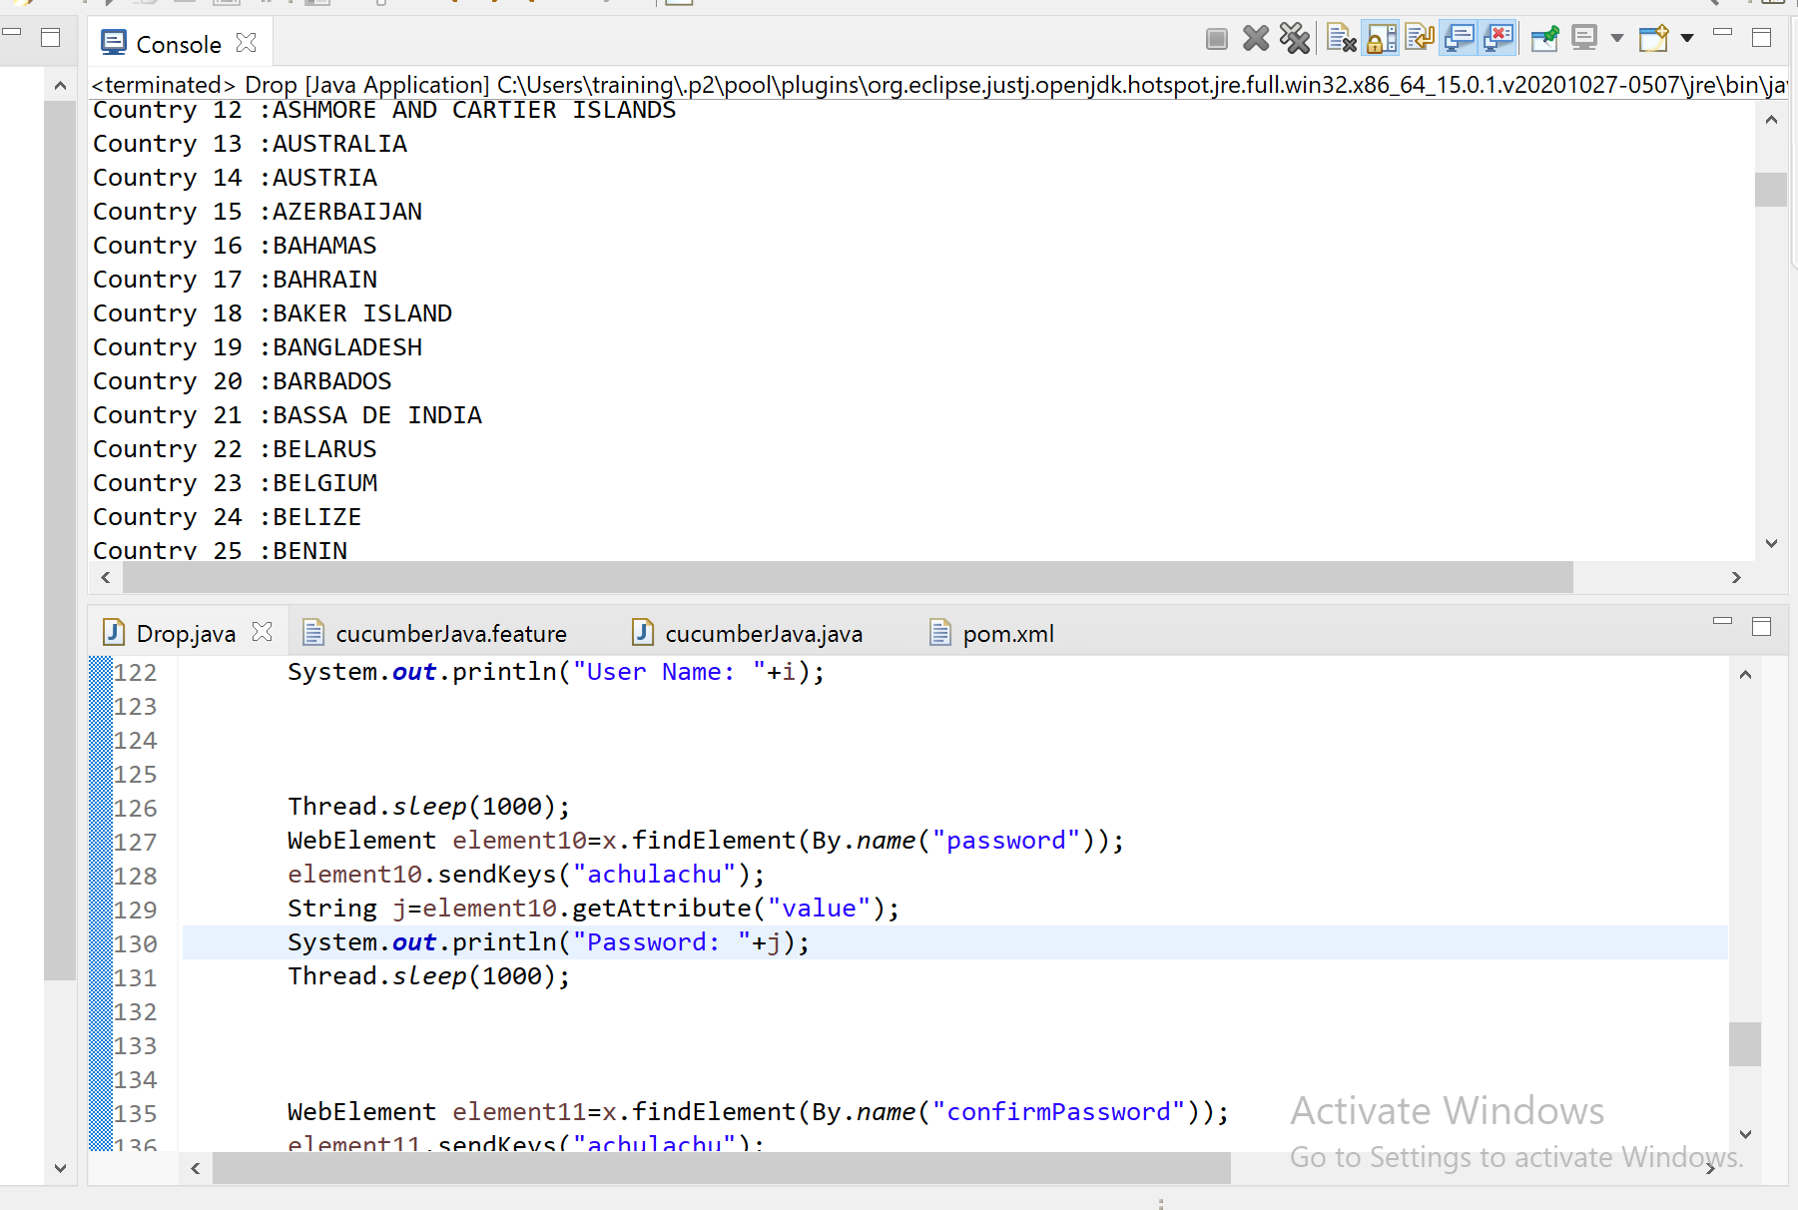

**4) Using testNG demonstrate parallel test executions in chrome and firefox**

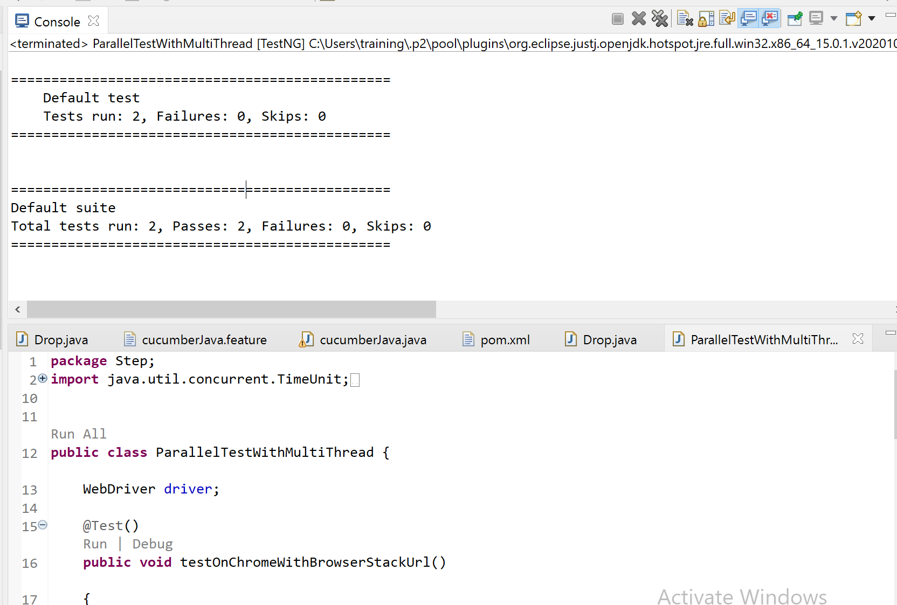

package Step;

import java.util.concurrent.TimeUnit;

import org.openqa.selenium.By;

import org.openqa.selenium.WebDriver;

import org.openqa.selenium.chrome.ChromeDriver;

import org.openqa.selenium.firefox.FirefoxDriver;

import org.testng.annotations.AfterClass;

import org.testng.annotations.Test;

public class ParallelTestWithMultiThread {

WebDriver driver;

@Test()

public void testOnChromeWithBrowserStackUrl()

{

System.setProperty("webdriver.chrome.driver", "C:\\Users\\training\\eclipse-workspace\\subartifactid\\src\\main\\resources\\chromedriver.exe");

driver=new ChromeDriver();

driver.manage().timeouts().implicitlyWait(10, TimeUnit.SECONDS);

driver.get("https://www.browserstack.com/");

driver.manage().window().maximize();

System.out.println("this is the test related to chrome browserstack homepage"+ " " +Thread.currentThread().getId());

}

@Test()

public void testOnChromeWithBrowserStackSignUp()

{

System.setProperty("webdriver.gecko.driver", "C:\\Users\\training\\eclipse-workspace\\subartifactid\\src\\main\\resources\\geckodriver.exe");

driver=new FirefoxDriver();

driver.manage().timeouts().implicitlyWait(10, TimeUnit.SECONDS);

driver.get("https://www.browserstack.com/users/sign_up");

driver.manage().window().maximize();

driver.findElement(By.id("user_full_name")).sendKeys("Dharini kavitha");

driver.findElement(By.id("user_email_login")).sendKeys("dharinikavitha@gmail.com");

driver.findElement(By.id("user_password")).sendKeys("browserstack");

System.out.println("this is the test related to chrome browserstack login"+ " " +Thread.currentThread().getId());

}

@AfterClass

public void close()

{

driver.quit();

}

}

**2) Write a program to find all the links from the new Maveric Website and print the same in excel using POI/Filo(**[**https://maveric-systems.com/**](https://maveric-systems.com/)**)**

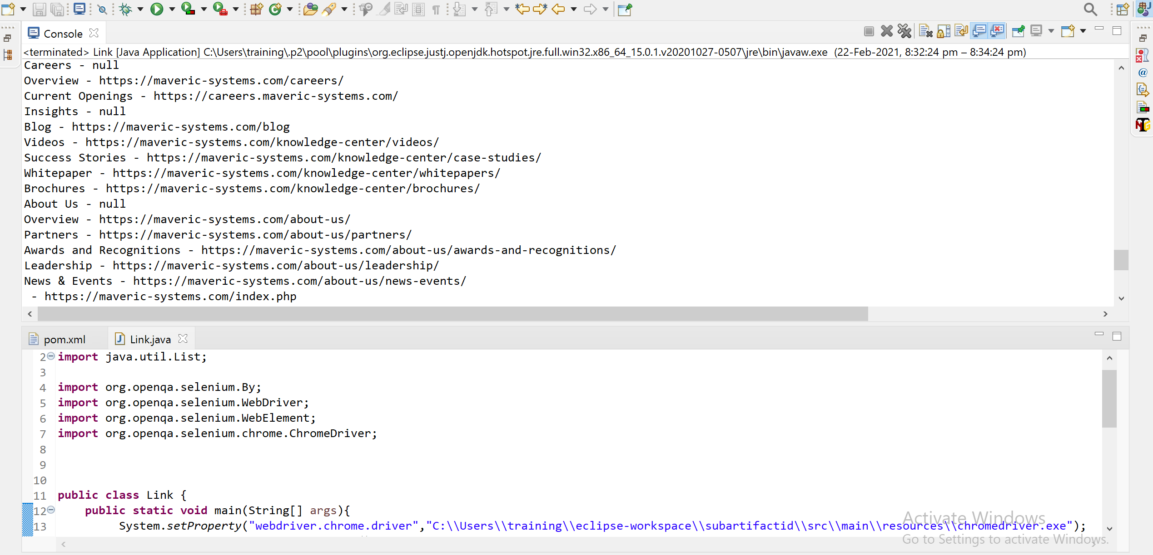

**package** Step;

**import** java.util.List;

**import** org.openqa.selenium.By;

**import** org.openqa.selenium.WebDriver;

**import** org.openqa.selenium.WebElement;

**import** org.openqa.selenium.chrome.ChromeDriver;

**public** **class** Link {

**public** **static** **void** main(String[] args){

System.*setProperty*("webdriver.chrome.driver","C:\\Users\\training\\eclipse-workspace\\subartifactid\\src\\main\\resources\\chromedriver.exe");

WebDriver driver = **new** ChromeDriver();

driver.get("https://maveric-systems.com/"

+ "");

driver.manage().window().maximize();

List<WebElement> allLinks = driver.findElements(By.*tagName*("a"));

**for**(WebElement link:allLinks){

System.***out***.println(link.getText() + " - " + link.getAttribute("href"));

}

}

}

**3.Write a program to extract all the values from web table and print it in excel using POI/Fillo (row-wise)**

<https://cosmocode.io/automation-practice-webtable/>

**package** Step;

**import** java.io.File;

**import** java.util.List;

**import** org.openqa.selenium.By;

**import** org.openqa.selenium.WebDriver;

**import** org.openqa.selenium.WebElement;

**import** org.openqa.selenium.chrome.ChromeDriver;

**import** org.openqa.selenium.chrome.ChromeOptions;

**import** org.openqa.selenium.support.ui.ExpectedConditions;

**import** org.openqa.selenium.support.ui.WebDriverWait;

**public** **class** WebtableTest {

**public** **static** **void** main (String[] args) {

File file = **new** File("C:\\Users\\training\\eclipse-workspace\\subartifactid\\src\\main\\resources\\chromedriver.exe");

String filePath = file.getAbsolutePath();

System.***out***.println(filePath);

System.*setProperty*("webdriver.chrome.driver", filePath);

ChromeOptions chromeOptions = **new** ChromeOptions();

chromeOptions.addArguments("start-maximized");

WebDriver driver = **new** ChromeDriver(chromeOptions);

driver.navigate().to("https://cosmocode.io/automation-practice-webtable/");

WebDriverWait wait = **new** WebDriverWait(driver, 30);

wait.until(ExpectedConditions.*visibilityOfElementLocated*(By.*xpath*("//table[@id='countries']")));

driver.findElement(By.*xpath*("//table/tbody/tr[1]/td"));

driver.findElements(By.*xpath*("//table[@id='countries']/tbody/tr"));

List<WebElement> lstRowWebelements = driver.findElements(By.*xpath*("//table[@id='countries']/tbody/tr"));

List<WebElement> lstColWebelements = driver.findElements(By.*xpath*("//table[@id='countries']/tbody/tr[1]/td"));

**int** rowCount = lstRowWebelements.size();

**int** colCount = lstColWebelements.size();

**int** row = 0;

**int** col=0;

**for**(row = 0;row<rowCount;row++) {

**for**(col=0; col<colCount;col++) {

String values = driver.findElement(By.*xpath*("//table[@id='countries']/tbody/tr["+(row+1)+"]/td["+(col+1)+"]")).getText();

System.***out***.println(driver.findElement(By.*xpath*("//table[@id='countries']/tbody/tr["+(row+1)+"]/td["+(col+1)+"]")).getText());

}

}

System.***out***.println("Row"+row);

System.***out***.println("Col"+col);

System.***out***.println();

row = row+1;

col= col+1;

System.***out***.println(driver.findElement(By.*xpath*("//table[@id='countries']/tbody/tr["+row+"]/td["+(col+1)+"]")).getText());

}

}

